**Technical Assessment**

***Instructions:***

* Produce a test automation script based on the scenario as detailed in the question.
* The script can be written in any language and using any tools.
* Run the script and generate the test execution report. The script and the report need to be uploaded into your Github repository. If you do not have a Github account, zip all the items and send it to the recruiter.

**Q1 (MANDATORY):**

* Navigate to <https://www.globalsqa.com/angularJs-protractor/BankingProject/#/login>.
* Login as *Bank Manager* and add customers as below:

|  |  |  |
| --- | --- | --- |
| **First Name** | **Last Name** | **Postcode** |
| Christopher | Connely | L789C349 |
| Frank | Christopher | A897N450 |
| Christopher | Minka | M098Q585 |
| Connely | Jackson | L789C349 |
| Jackson | Frank | L789C349 |
| Minka | Jackson | A897N450 |
| Jackson | Connely | L789C349 |
| Lawrence | Zimmerman | L789C349 |
| Mariotte | Tova | L789C349 |

* Go to *Customers Tab*, verify that all the customers are inserted in the table.
* Delete specific customers:

|  |  |  |
| --- | --- | --- |
| **First Name** | **Last Name** | **Postcode** |
| Jackson | Frank | L789C349 |
| Christopher | Connely | L789C349 |

**Q2 (OPTIONAL):**

* Navigate to <https://www.globalsqa.com/angularJs-protractor/BankingProject/#/login>.
* Click *Customer Login*.
* Choose **Your Name as Hermoine Granger and Login.**
* Choose **“1003”** in the drop down. Verify that initial Balance is **0**.

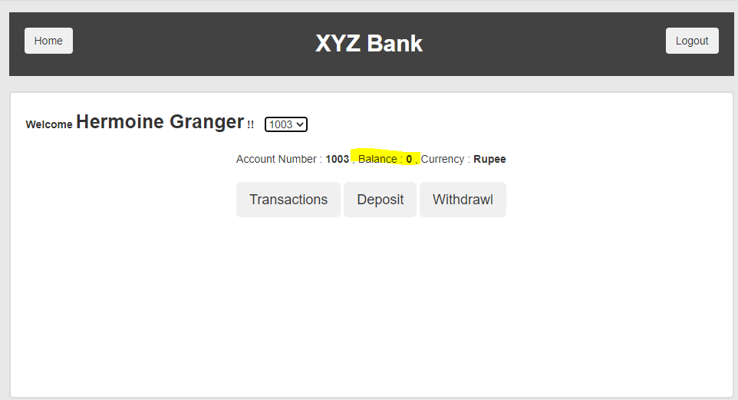

* Perform debit and credit transaction as above. Using calculation, determine current balance of the account after each transaction. Verify that the current balance tallies with *Balance* section in the *Customer Homepage*.

**Transaction:**

|  |  |  |
| --- | --- | --- |
| Amount | Transaction Type | Current Balance |
| 50000 | Credit |  |
| 3000 | Debit |  |
| 2000 | Debit |  |
| 5000 | Credit |  |
| 10000 | Debit |  |
| 15000 | Debit |  |
| 1500 | Credit |  |